Criteria 6.2.2
The functioning of the institutional bodies is effective and efficient as visible from policies, administrative setup appointment and service rules, procedures, etc.
The Governing Structure at IMI Bhubaneswar comprises of multiple layers. At the top is the Governing Body comprising of eminent individuals. The Governing Board is assisted in its responsibility to fulfill the mission statements by three sub-committees: (1) Finance committee; (2) Infrastructure committee; and (3) Steering committee. The institution is supported in its endeavor to fulfill its’ stated vision and mission by the Academic Advisory Council comprising of academicians and experts from the industry. They meet regularly to fine-tune the course curriculum in alignment of PSOs and towards fulfillment of POs. The overall academic ambience of the institution is maintained by the Faculty Council (FC). The FC meets regularly to discuss all important issues. Collective decision-making is the norm at IMI, Bhubaneswar. The FC is supported by the respective Area Chairs and individual faculty members.

Organogram of IMI, Bhubaneswar

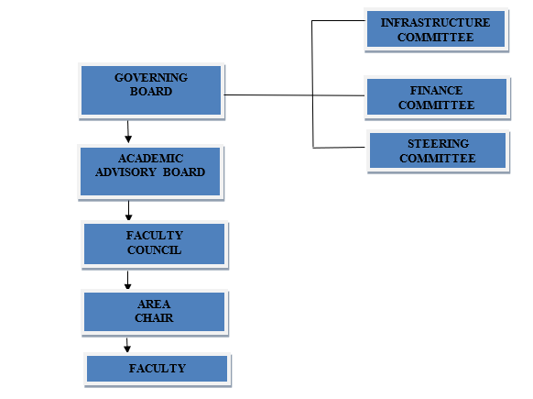
ADMINISTRATION
IMI Bhubaneswar has adopted a transparent process for appointment of administrative setup and service rules for a transparent governance. The guidelines for functional operations, assessment of performance and rewards associated with the levels of performance is well articulated in the service rules and circulated among all the stakeholders. IMI Bhubaneswar has a very well laid down Service Rule document to govern various activities and also to measure the output of such activities. IMI Service Rules are shared with faculty and staff.
To motivate its personnel and to ensure a work-life balance, IMI has put in place a robust leave policy for all employees. Apart from these leaves, IMI Bhubaneswar also provides LTC to facilitate its faculty members to go on paid vacations every alternate year. IMI treats its students, staff and faculty members as family. IMI Bhubaneswar provides internal grant for faculty development and for research. IMI Bhubaneswar also encourages its faculty to attend national and international conferences as part of its faculty retention policy. Most of the IMI faculty members have availed this facility over the years IMI has put in place an exhaustive Service Rule for its faculty and staff members to realize their full potential in research by facilitating their personal development.
As IMI Bhubaneswar believes in collective leadership and sharing collective responsibility, utmost transparency is maintained by the Governing Board and Faculty Council with regard to all the policy related decisions with respect to academic and non-academic activities. To ensure accountability, all the stakeholders are involved in major policy related decision-making process. IMI, Bhubaneswar maintains the records of all its activities with regard to policy related matters on a regular basis and the management periodically reviews these records to identify the gap areas to strengthen the transparency.

